LAB SHEET – 5 IT24101423

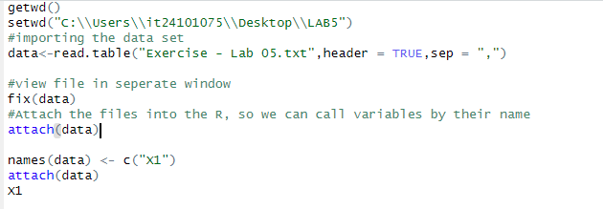

2)

3)

* Most deliveries happen between 30 and 50 units of time.
* The most common delivery time is around 40.
* There are fewer very fast or very slow deliveries.
* The times are spread out but mostly centered around 40.

